1. 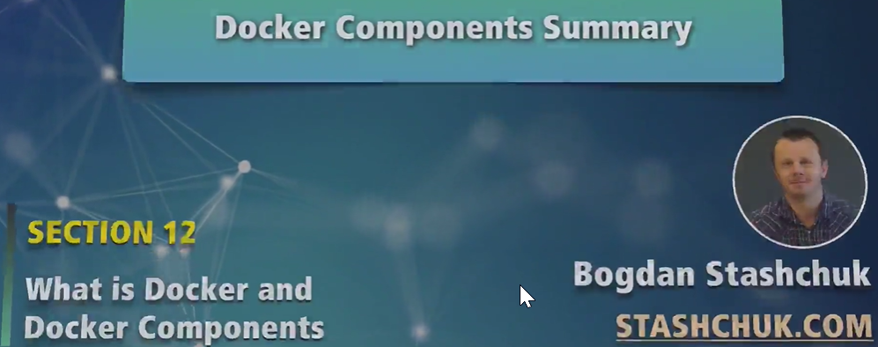
2. We have studied most important components from Docker.
3. Let’s see how those components interact with each other.
4. 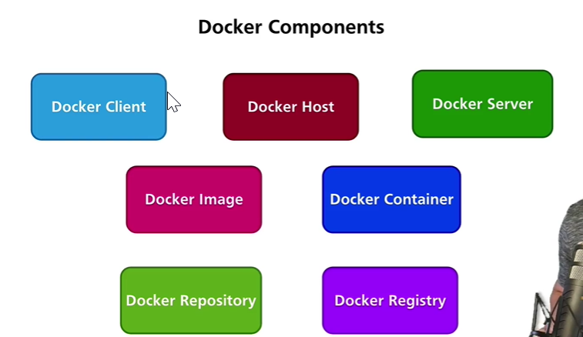
5. 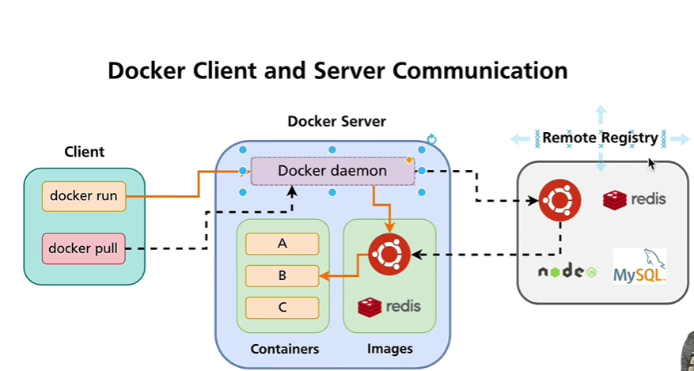
6. When a container is created, a no of other processes happen such as
   1. Every container gets a unique IP address.
   2. A new file system layer is created for each container.
   3. Every container has at least one process and that is started.
   4. All of these are managed by Docker Engine.
   5. All of these processes run in Docker Host (Linux Environment).